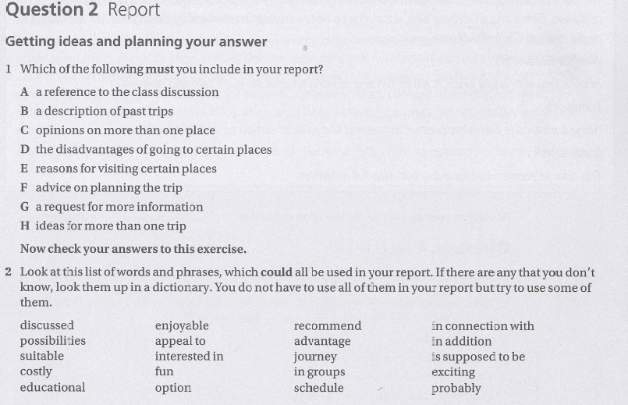

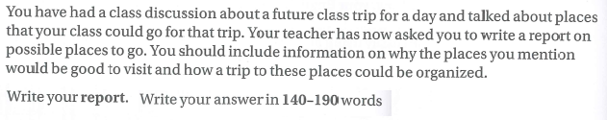

ANSWER FOR EXERCISE 1

A,C,E,F

MODEL ANSWER

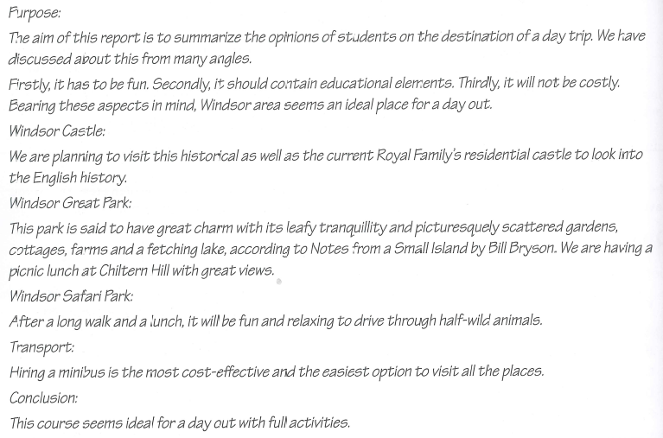

NOW IT’S YOUR TURN

|  |
| --- |
| REPORT: |
|  |